Native Trees and Community Woodlands for Local Carbon Storage

Introduction

This practical project, The Woodland League “Forest in a Box”, has been designed to inspire the creation of community native woodlands for local carbon storage whereby local communities can take responsibility for their own carbon emissions. This will enable local community action to combat Climate change in a very simple, direct and effective way.

Native trees & carbon

A healthy tree stores approximately 13lbs of Carbon annually, this is 2.6 tons per acre. An acre of trees absorbs enough C02 over one year equal to amount produced by a car driven 26,000 miles. Planting trees remains one of the cheapest most cost effective means of drawing excess C02 from the atmosphere. ( US Forest Service )

Seven to nine tons of carbon emissions are generated by the average Irish household every year. You can balance your carbon simply, by planting native trees. ( UK Woodland Trust ). Native tree planting has a positive impact on the removal of carbon from the atmosphere - and native woodland provides vital new places to help people and wildlife deal with Climate change. Twenty five square metres of mixed native woodland will capture and store one ton of carbon dioxide during its lifetime.
Leading author and ecologist, the late, Oliver Rackham, one of the greatest experts on native woodland, whose research has changed the global understanding of the importance and value of native woodlands, maintains that well managed native woodland is an infinitely sustainable resource.

In a UK based Native Woodland Trust publication we discover that in one acre of native woodland, there are,
- 4 tons of Bacteria.
- 1.5 tons of Fungi.
- .5 tons of Field plants.
- 500 lbs of Earthworms.
- 340 lbs of Protozoa,
- 90lbs of Slugs and Snails,
- 50lbs of Spiders,
- 9lbs of Beetles,
All busy building themselves from Carbon and sustaining local biodiversity.
Our native trees and woodlands with their deep root systems can soak up and recycle approximately 38% of rainwater back into the atmosphere during the growing season and store water in their deep leaf litter forest floor during the dormant season. A profile of their associated insects shows oak with 284, Willow with 266, Birch with 229, Hawthorn with 149, Hazel with 83, Alder with 90, and Scots Pine with 91.
Additional benefits of native community woodlands
The potential of the Tuamgraney community native woodland model, in Tuamgraney, County Clare, managed by a partnership of The Woodland League, CELT (centre for environmental living and training), and the local community is explained below in a summary.

The project is a unique example of allowing nature to lead the way for the restoration of a native woodland. Through the process of natural regeneration with minimal human intervention, the project is evolving as the forest conditions are changing and adapting to allow for what is known as the climax vegetation of oak trees to dominate the canopy once again.

In 2008 with the guidance of qualified ecologist, Aidan Corcoran, the woodland was divided into 50 10m x 10m plots on a grid and comprehensively surveyed, for trees and ground cover. Every tree above 2cm diameter was recorded and mapped on the grid. This information will allow for the woodland to have a very valuable educational aspect, once the secondary surveying has been completed this is being done at the moment. When the two sets of data are compared we will see how much carbon has been locked up, what changes have occurred on the ground, which trees have been removed to allow for oak planting, etc. The original survey information is all on the website with a web page for each plot and when the new data is uploaded we will have an interactive educational resource which will enable secondary schools in particular to engage fully with the project.

A partnership has been made with an award winning Irish company called Treemetrics
( info@treemetrics.com ) who have developed a 3D camera capable of measuring the carbon/wood content and identifying each tree in the woodland. This links up with satellite technology and GPS information that will allow us to create a 3D map of the woodland in real time. In effect this means that schools will be able to actually watch the trees growing on a daily basis and all future interventions will be recorded immediately. Treemetrics wish to become involved to show their commitment to Corporate Social Responsibility and to this end are offering us access to their technology for free in the form of an APP.

This will allow visitors to the woodland to access all the information via their mobile phone and have personal guided tours explaining the whole process; this will prove very valuable for tourist visitors. It also opens up the possibility of linking schools in other parts of Ireland as well as other countries too, directly to the Community woodland as an educational resource free to access. The woodland restoration model can then be adapted and copied nationally and globally, furthering its value.

This real time informational ability will compliment the hard data obtained from the physical surveying and allow schools to project how the woodland will look in the future as well as play with different hypothetical scenarios. In time the technology may also be able to identify the ground flora which then enables Biodiversity and carbon storage to be measured extremely accurately. This will present spin off opportunities for engaging geography, mathematics, biology, etc, using the woodland as the model. For adults the woodland will become an ongoing training and learning facility as well, for woodland management, ecology, biodiversity, etc. All of this can be shared nationally and globally, highlighting the empowerment aspect of the project for local communities to take responsibility for their own environmental protection and biodiversity enhancement.

The Sustainable woodland management model in place in Tuamgraney follows the definition agreed at the Rio in 1993, laid down in the Convention on Biological Diversity, a legally binding international agreement to halt Biodiversity loss and decline and includes the use of resources in such a way and at a rate that does not lead to the long term decline of Biodiversity. By selective felling, control of invasive species and coppice management, allowing generous areas and margins for their own evolution, people centred, labour intensive, and locally based, this is guaranteed. Coppicing is an ancient wise system of management that entails rotational cutting of broadleaf trees allowing the stumps to regenerate at different time intervals. This prolongs the life of the tree and ensures more carbon lock up into the future. A hazel tree left to its own devices may live up to about 150 years, when it is coppiced it can supply c. 37 human generations at 40 years a generation, with abundant protein rich hazel nuts, browsing for farm animals, poles for wattle and daub building, hurdles and fences, broom handles, etc.
The use of wood thinnings for local firewood, for the making of brash piles in the wood for insects, small animal’s habitat and some american red oak, which came down in the storm, for making benches. This highlights sustainable use of local materials to the community and shows the potential for promoting sustainable rural livelihoods, by including crafts and other woodland revenue sources including non timber, such as edible fungi, nuts and berries, use of leaves and flowers for natural forest wreaths and flower arrangements. UK department for international development definition of same is " A livelihood comprises the capabilities, assets ( including both material and social resources ) and activities required for a means of living. A livelihood is sustainable when it can cope with and recover from stresses and shocks and maintain or enhance its capabilities now and into the future, while not undermining the natural resource base".

This in turn improves the community resilience in line with the aims of Sustainable Development meeting present needs, economic security, shelter, health, food, education, political representation, open space, contact with nature, intergenerational bottom up learning and exchange of information, in an integrated way. Without compromising the ability of future generations to meet their own needs, via cutting down the use of non renewable resources like oil, coal and gas, minimising waste and pollution while protecting natural resources. Creating community native woodlands teaches people to work together with others and with nature which in turn leaves a healthy community as a natural by product.
Act locally think globally
Diana Beresford-Kroeger the Woodland League consultant scientist and best selling author has included film footage of the Tuamgraney community native woodland as part of her film currently on global release “Call of the Forest the Forgotten Wisdom of Trees” , to inspire global native forest restoration. The Woodland League “Forest in a Box” project answers the “Call of the Forest”. Diana’s scientific work on the medicinal properties of trees has been ground breaking, to say the least, she has also mapped the nervous systems of trees and shown the similarities to our own nervous systems.

The late Biologist and author, E.O. Wilson, who coined the phrase Biodiversity referred to Diana as a visionary.
“Perhaps the time has come to cease calling it the 'environmentalist' view, as though it were a lobbying effort outside the mainstream of human activity, and to start calling it the real-world view.”
― Edward O. Wilson
Native trees for health.

According to a conference organised by the National Urban Forestry Unit on the subject of Trees for Health in the UK in 2000 attended by many doctors and health care officials as well as environmentalists and foresters. The following information is taken from notes taken at this conference by Dr Ian Humphreys, Millennium Tree Campaign Manager based in Belfast.

Just looking at a tree and spending any time close to trees is good for your health! In fact trees are so good that one GP commented that the NHS should be renamed, The National Medical Care and Nursing Service because environmentalists are the real Health service!

But first what is health?
" Health is a complete sense of social and mental well being, not just an absence of disease ".

Trees are amazing filterers, removing particulate and gaseous matter from the atmosphere.
Some examples of modern prevalent pollutants,
- Ground level ozone - produced from photochemical reactions of certain air pollutants.
- Particulate matter - found in smoke, dust and car emissions.
- Nitrous oxides - produced by burning fuel in boilers and cars, etc.
Mortality rates increase when levels of fine particulate matter ( as released by Diesel vehicles, which have become the most popular type of car being sold these days )

Trees remove pollutants; Oak trees can remove 425kg of dust per hectare per year. In Chicago where tree cover is at 11%, it has been calculated that trees remove 1.17 tons of carbon monoxide, 2.93 tons of sulphur dioxide, 3.98 tons of nitrogen oxides, 4.21 tons of ozone, and 5.3 tons of particulate matter (PM10's).
It is very clear that we in Ireland with our lowest tree-cover in the EU need more trees, especially in our populated areas, especially around schools.

Trees as Tranquilisers.

Most people when asked where they go to relax, respond by saying, to the natural environment, mainly wooded areas. It was this belief that viewing trees was good psychologically and sometimes physically that led to city parks being created -

" Nature recreated in cities brings tranquility to the mind ".
Today, many people suffer from stress, this causes negative effects on health: -
Psychologically it causes tension, anger and depression. Physically it increases blood pressure and suppresses the immune system, this causes sleeplessness, reduced thinking performance, alcohol abuse and outbursts of hostility.

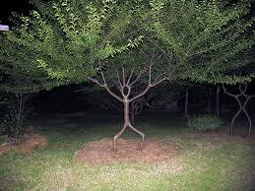

The Dunemann Bed

A Close To Nature Native Tree Seedling Propagation System.

This is the copy nature forest floor seedling incubator system employed in The Woodland League “Forest in a Box” project. We would like to acknowledge Tony Adams in west Cork for introducing us to this amazing practical tree growing system.

What is a Dunemann Bed – how is it different from a standard tree nursery system for growing young tree saplings from seed.

The Dunemann system was developed by a German forester who noticed trees growing naturally on the natural forest floor were extremely healthy due to the conditions provided by nature in the natural forest. He then decided to experiment by copying this natural way to grow trees with great success. The intention is to optimise the health and vigour of the saplings by recreating as much as possible the forest floor in which they would naturally be growing as part of natural regeneration.

This system uses deep beds of loosely packed leaf mould into which tree seed is sown. Only leaf mould/mulch is used as a growing medium in the bed, and no compost, soil or other growing mediums should be put inside it.

Its main purposes are to –

• Optimise the health and vigour of young tree saplings by recreating the forest floor
conditions where they would naturally grow.

• Loosely packed leaf mould allows for good root penetration.

• The bed gives some protection from wind and cold in the saplings first 12” of growth,
and the trees are easy to lift out afterwards.

• Protection from birds, rodents and other creatures.

• Trees use fungi to help them draw nutrients from the earth and their surroundings.
They have a symbiotic relationship with these fungi known as ‘mychorriza’. But
unfortunately these fungi are easily killed off by conventional chemical fertilisers and
pesticides leaving the tree in a more vulnerable state. The leaf mould is especially good
for helping the saplings connect with these fungi immediately, after which they should
be grown in soil free from chemicals so that they can continue to grow healthily.

What is leaf mould/mulch, and what type of leaf mould/mulch is used ?

Leaf mould is what you are left with once leaves break down fully into a substance that looks much like garden compost. It can take up to two years for leaves to break down. For the Dunemann bed we use a mixture of deciduous and coniferous leaf mould. We also try to make sure that some of the deciduous leaves are from the oak, birch or beech tree, as these trees are excellent for supporting fungi, an essential ingredient for helping the young saplings develop a beneficial relationship with the fungi so that they can draw nutrients easily from the earth.

What type of tree seeds can you grow in the bed?

The Dunemann bed is particularly suited for growing trees which have large edible seeds
that usually germinate the Spring after which they were formed e.g. Oak, Hazel, Beech and Sweet Chestnut. However, it is suitable for growing all types of trees, just remember that
some seeds take a lot longer to germinate than others, such as Holly which can take around
five years!

Advice for bed preparation.

Before building the beds It is wise to thoroughly fork over the ground to clear perennial weed roots, particularly the nettle if they had covered the site previously. Then, after the beds are built, put in the growing medium, preferably starting with a layer of well-rotted manure, followed by alternating layers of deciduous and coniferous leaf-mould preferably two years old. This can be found by scraping away the top layer of leaf litter to get at the wetter decomposing leaves from the previous year. Remember it can take up to two years for leaves to break down. It is also helpful to sprinkle layers of seaweed dust, (for its supply of various trace elements in organic form), and calcified seaweed with added rock phosphate and rock potash for good root development. Aim for approximately 6" of added organic matter to the beds, mostly leaf-mould.

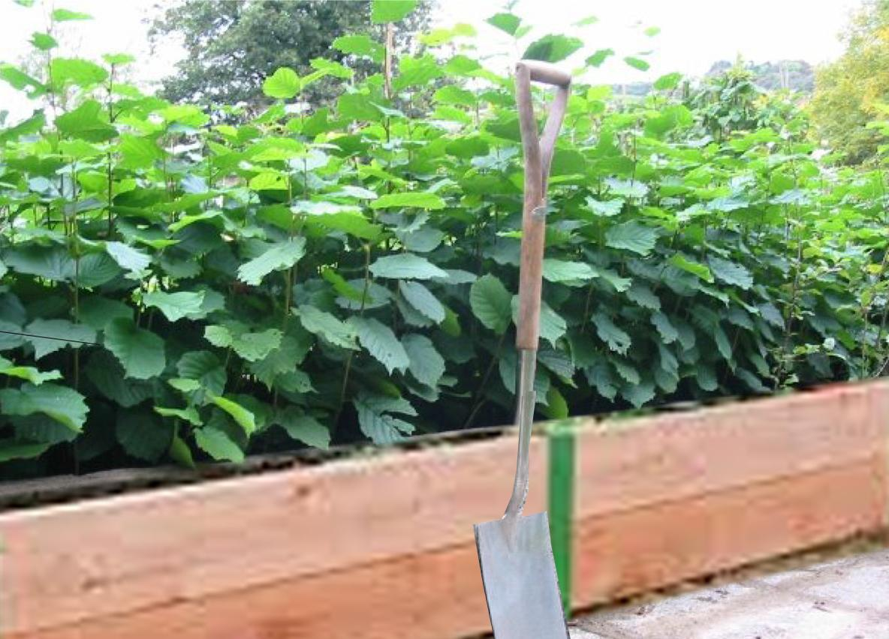
One metre high hazel saplings after one year growing in the Dunemann Bed.

